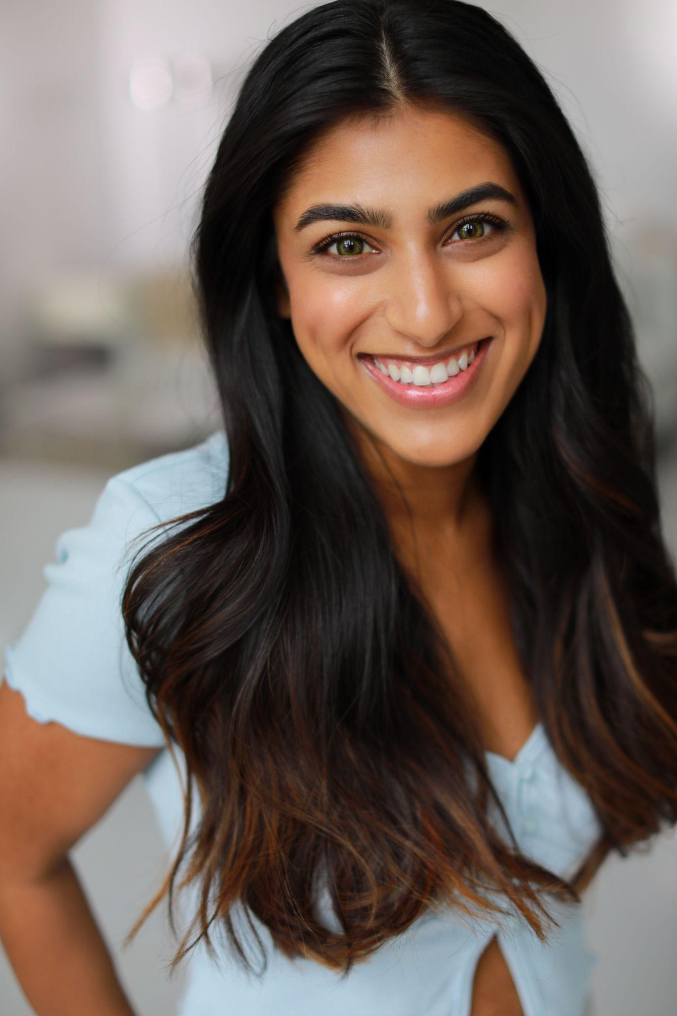
ASHA DEVI
www.AshaDeviNYC.com

Hair: Brown|Eyes: Green Height: 5’0|Weight: 108 lbs

FILM
Rising Lotus (Nice International Film Festival Winner) Supporting dir. Gurinder Singh
Purpose Lead dir. Jennifer Arjune
Do Robins Sing? Lead dir. Cooper Constantino
Strangers Lead dir. Muskaan Vatvani
The Yellow Wallpaper Lead dir. TJ Cerasi
The Colored Girl Chronicles Supporting dir. Dexcee Lowe
Black Cake Lead dir. Megan Channell
THEATRE
The Kew Hera Rachel Naomi Hilson, Joosje Duk
The Ramayana Sumitra/Kali/Tataka Mika Wiley
The Knot Pushpa Karishma Bhagani
Huma Dreams Huma Abedin Alexis Spiegel
Repulsing the Monkey Sophia Daniel Leeman Smith
Birdbrain Avery Forbes Amanda Alch
Fish Tank Maddie Bryan Hagelin
She Kills Monsters Narrator/Farrah Justin Giachetti
Double Happiness Cindy Dennis Yueh-Ye Li
Around the World in 80 Days Aouda Randall Frizado
Stormé Diana Carolyn Brown
The Leading Lady Club Actor 4 Jennie Hughes
TRAINING- NYU Tisch BFA in Drama
New York University Tisch School of the Arts (Experimental Theatre Wing & Stonestreet Studios)
Acting- Tina Shepard, Andrea Arden Reese, Kevin Kuhlke, Terry Knickerbocker, Andy Roth(more)
Voice- Karen Braga (Alexander), Jonathan Hart, Louis Colianni (Linklater), Aysan Celik, Lisa Sokolov
Movement- Michelle Uranowitz, KJ Holmes (contact improv), Wendell Beavers, Martha Tornay, Pat Hall, Barney O’Hanlon
Terry Knickerbocker Studio
Acting Terry Knickerbocker
Clown Justin Cimeno
Viewpoints Nicolas Noreña
New York Film Academy
Acting for Film Bela Grushka, Alfie Fuller
The Lee Strasberg Theatre and Film Institute
Midsummer Intensive Tim Crouse, Remington Moses, Suzanne DiDonna, Marcel Simoneau
SPECIAL SKILLS
Improv, Stage Combat, Eskrima, Aikido, Afro-Haitian Dance, Contact Improv; Vaccinated and Boosted; Driver’s License and Passport. Accents: Guyanese, Trinidadian, British (RP), Indian, French, Transatlantic; More upon request.
Company Member of Rising Sun Performance Company

